The Anti-Bias Award Guidelines

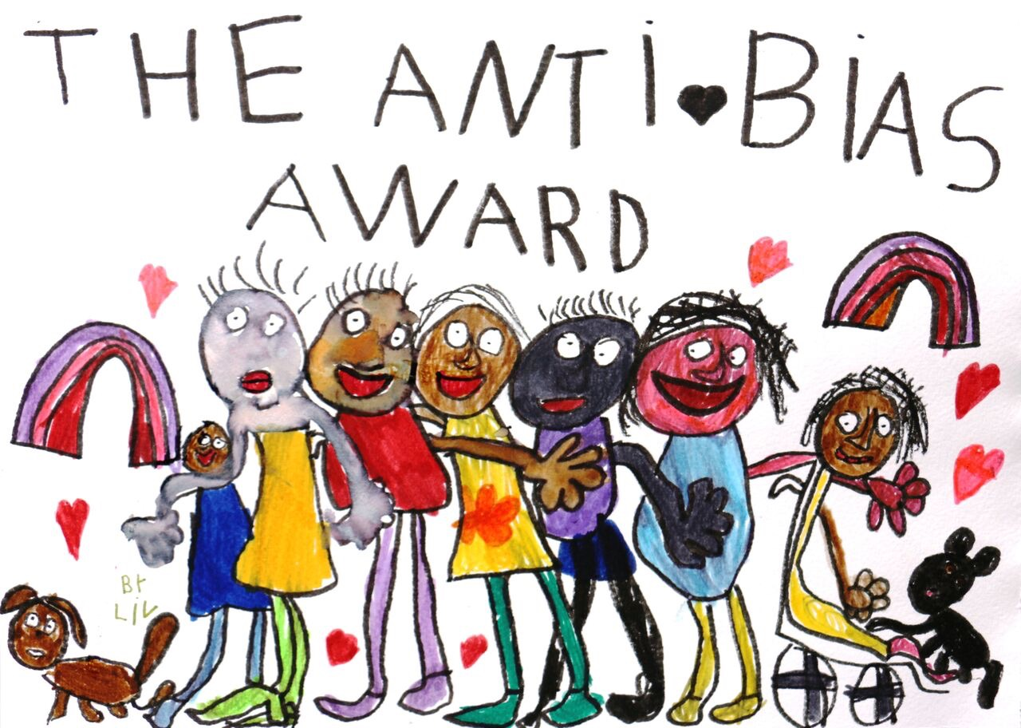

NOMINATIONS NOW OPEN UNTIL 5pm on 27 June 2025

How do I nominate?

Complete the form on page 5

Provide a summary explaining how you or someone you work with meet the selection criteria detailed on page 6. The summary may be written (up to 1000 words), video (up to 5 minutes), podcast/voice recording (up to 5 minutes) or mixed media of your choice. You are limited only by your imagination.

Email the form (page 5), your summary (page 6) and any supporting documents to foundation@sjiec.org

Purpose of the Award
The Anti-Bias Award is an annual award presented by Social Justice In Early Childhood Foundation. This award has been designed to encourage early childhood professionals from across the field of early childhood to engage with anti-bias approaches, as well as to recognise early childhood professionals for their pedagogical leadership in making anti-bias practices central to the everyday rather than an ‘add on’ to practice.
The Anti-Bias Approach in Early Childhood (4th Ed) edited by Dr Red Ruby Scarlet has been integral to both quality and equality in early childhood education. Since its initial publication in 1995, this book has informed practice across the country – in all types of services, in professional development workshops and programs, and in tertiary training and education courses. Anti-bias approaches have been the cornerstone of numerous teacher-research and practice-based studies undertaken in Australia. These studies are unique because they are teacher-research undertaken by early childhood teachers for early childhood educators and teachers. While parts of the profession have sustained the use of anti-bias approaches in their practice, the speed at which the field is growing, and the ever-changing policy landscape has caused anti-bias approaches to be less familiar to many professionals and less explicit in everyday practice. This award is one way to recognise those keeping the work alive.

How are award winners recognised?
The Anti-Bias Award will be presented in person at the annual Social Justice in Early Childhood Conference, the 21st Throwing the baby out with the bathwater on Saturday 26 July 2025.
Award winners will receive:
- A framed award certificate acknowledging their achievements and contributions
- a $500 cash prize from the SJIEC Foundation to spend on furthering their anti-bias work
- An invitation to present at a SJIEC Conference or event (online or in person)
- An invitation to join the SJIEC Emissaries
- Prize from partner associations

Who can apply or be nominated?
There are 2 categories for the Award:
- Anti-Bias Award for an individual (Individual Award)
- Anti-Bias Award for a group, pair, organisation or collective (Collaborative Award)
Individual Award
Eligible applicants or nominees include those who:
- hold any early childhood qualifications or credentials; and
- have a minimum of five years face-to-face experience working with children under 12 years.
Collaborative Award
Eligible applicants or nominees include any pair, group, organisation or collective, where the majority of members each meet the criteria for the Individual Award.

How do I apply or nominate?

Complete the form on page 5

Provide a summary explaining how you meet the selection criteria detailed on page 6. The summary may be written (up to 1000 words), video (up to 5 minutes), podcast/voice recording (up to 5 minutes) or mixed media of your choice. You are limited only by your imagination.

Email the form (page 5), your summary (page 6) and any supporting documents to foundation@sjiec.org

What criteria will be used to select the award winners?
The award selection committee will review each nomination to ensure they meet the eligibility criteria (Who can be nominated?) and then decide the award winners based on how well each:
- engages with the four Anti-Bias goals in everyday practice
- embeds Anti-Bias approaches in their practice in sustained ways

When are applications and nominations due?
To be considered, completed forms must be submitted by 5pm on 27 June 2025.

What happens after I submit my nomination?
Award winners will be notified by email by 11th July 2025 and presented their award at the Social Justice in Early Childhood Conference on Saturday 26 July 2025.

Supporting Documentation
Supporting documentation is not a requirement but may strengthen your application or nomination. Any supporting documents should be in PDF or include a link to a URL. Examples include but are not limited to:
- curriculum documentation (with permission from children and families)
- testimonies from children or families
- articles published in professional publications, scholarly books or journals
- family and community newsletters
- images, text, artwork, blogs, vlogs or other media/platforms
- relevant excerpts from Quality Improvement Plans or other service documentation.


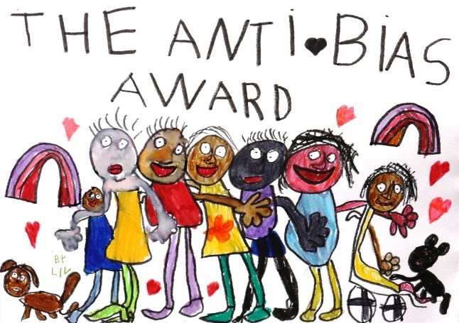

Section 1 – Application or nomination details

Award category (select one)

Anti-Bias Award for an individual (Individual Award)

Anti-Bias Award for group/pair/organisation/collective (Collective Award)

In what capacity are you making this nomination?

I am nominating a deserving collective (and I have the necessary permission to share the details of their work)

Name of nominee (Individual or group)

Current position (Individual category only)

Details of early childhood qualification/ certification held by nominee (Include award, date, institution, certifying authority)

Employment history relevant to the application or nomination (Not required for organization/group nominee)

Name and contact details of an ECEC professional referee who supports the application or nomination (A member of the selection committee will contact the referee as part of the selection process to verify the details of the Anti-bias work described in the written statement)

